Fast**National University of Computer & Emerging Sciences, Karachi  
Fall-2017 CS-Department  
MidTerm II   
26th October 2017, 1:00 pm – 02:00 pm**

|  |  |  |
| --- | --- | --- |
| **Course Code: CS301** | **Course Name: Theory of Automata** | |
| **Instructor Name: Muhammad Shahzad** | | |
| **Student Roll No:** | | **Section No:** |

Instructions:

* Return the question paper.
* Read each question completely before answering it. There are **4 questions and 2 pages.**
* In case of any ambiguity, you may make assumption. But your assumption should not contradict any statement in the question paper.
* All the answers must be solved according to the sequence given in the question paper.

**Time**: 60 minutes. **Max Marks**: 40 points

Question 1: State whether True or False – *To get any credit justify your answer*: [10 points]

1. There is a regular language L for which there is exactly one regular expression R with L(R) = L.

2. Intersection of two non-regular languages is always non-regular.

3. Given a non-regular language L1, {L1 U (L1)R} – where (L1)R is the reversal of L1, will always be a regular

language.

4. The complement of a non-regular language must be non-regular.

5. Let L4 = L1L2L3. If L1 and L2 are regular and L3 is not regular, it is possible that L4 is regular.

6. Every subset of a regular language is regular.

7. If, two strings x and y, defined over Σ, are run over an FA accepting the language L, then x and y are said to belong to the same class if they end in the same state, no matter that state is final or not.

8. Let FA3 be an FA corresponding to FA1+FA2, then the initial state of FA3 must correspond to the initial state of FA1 or FA2

9. If L1 and L2 are expressed by regular expressions r1 and  r2, respectively then the language expressed by  r1 + r2 will be regular.

10.  Pumping lemma is generally used to prove that A given language is regular

**1/2**

Question 2: Consider the following NFA- λ, construct an equivalent DFA. Show all steps [10 points]



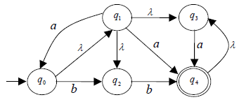

Note: λ represents the *empty string*.

Question 3: Minimize the following DFA using partioning method: [10 points]

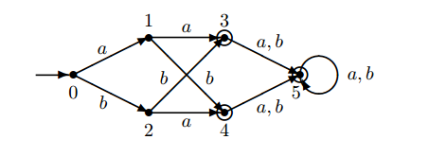

Question 4: Assume alphabet $∑$ = {a, b}. Prove or disprove that following languages are regular. Negative marking for using example(s). [10 points]

**B.** L = {anbmcm*n | m, n >= 0}.

**C.** L = {anbn | 3 > n > 1}.

**2/2**